**BUSINESS**

**WRITING**

**Professional Development Program**

**28th June 2016**

**Presenter**

**Kathleen Tooher**

**THE PLAN!**

* Discuss etiquette guidelines for professional business writing -**Task**
* Mini-case study
* Analyse emails discussing levels of formality in internal and external correspondence, and common layout features -**Tasks**
* Identify most common mistakes made in tone, levels of formality, word choice and sentence/phrase construction –**Tasks and Mistakes Muddle** (Pair work)
* Review Mistakes Muddle Task and note general points to bear in mind
* Time? Additional exercises with reports (or take-home)
* **Q & A / Audience & Advice to Peers**

***\*Task***

*Write your ideas below.*

5 Golden Rules

**THE BASICS**

* Make sure you are clear about what you want to say
* Make sure the message is presented in a logical way
* Stick to a paragraph for each step
* Identify the subject immediately

(email subject, or in a letter as a subject title)

* End by pointing the way ahead
* Use simple, short sentences (KISS principle)
* Punctuate for clear meaning

(also to remove any possible ambiguity)

* Remember, layout (the look of it) is important.

(It has to look, and be ***‘digestible’***, otherwise it will just get **deleted** or ***‘put in the too hard basket’***)

* Remain polite, no matter how angry you feel!

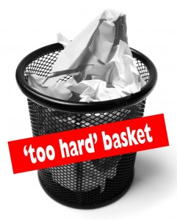

Don’t use CAPITAL LETTERS in an email message, and avoid these things!!!

(It could be perceived as the equivalent of shouting at someone!)

Anything else ????

How similar was your list?

**BRIEF ACCURATE CLEAR COURTEOUS**

Keep in mind the following questions, whenever you put ‘*pen to paper’.*

*What is my message?  
Do I have all the necessary information?  
In which order should I present this information?  
What type of person am I trying to communicate with & how well do I know them?*

**THE BASICS OF EMAIL WRITING**

**\*\*Making a strong start \*\*Being friendly & diplomatic \*\*Being formal**

As people in business often receive a huge number of emails, it is important to ensure that yours will be noticed and read.

**\*Task** *Look at the strategies 1-5 for getting the attention of the reader, and match them with the parts a-e of the email below.*

1. Emphasise key information or any action that is required (e.g. if you need a response by a certain date).

2. Include a relevant subject line to clarify the purpose of the email.

3. Provide any necessary context or background information that the reader will need.

4. Open with an appropriate salutation (*Hi* …*Hello* … for people that you know and *Dear* … for someone you are contacting for the first time).

5. When consolidating contact, refer to when and where you met the person.

**ANTICIPATE / ‘JUDGE’ > PLAN > COMPOSE > EDIT**

*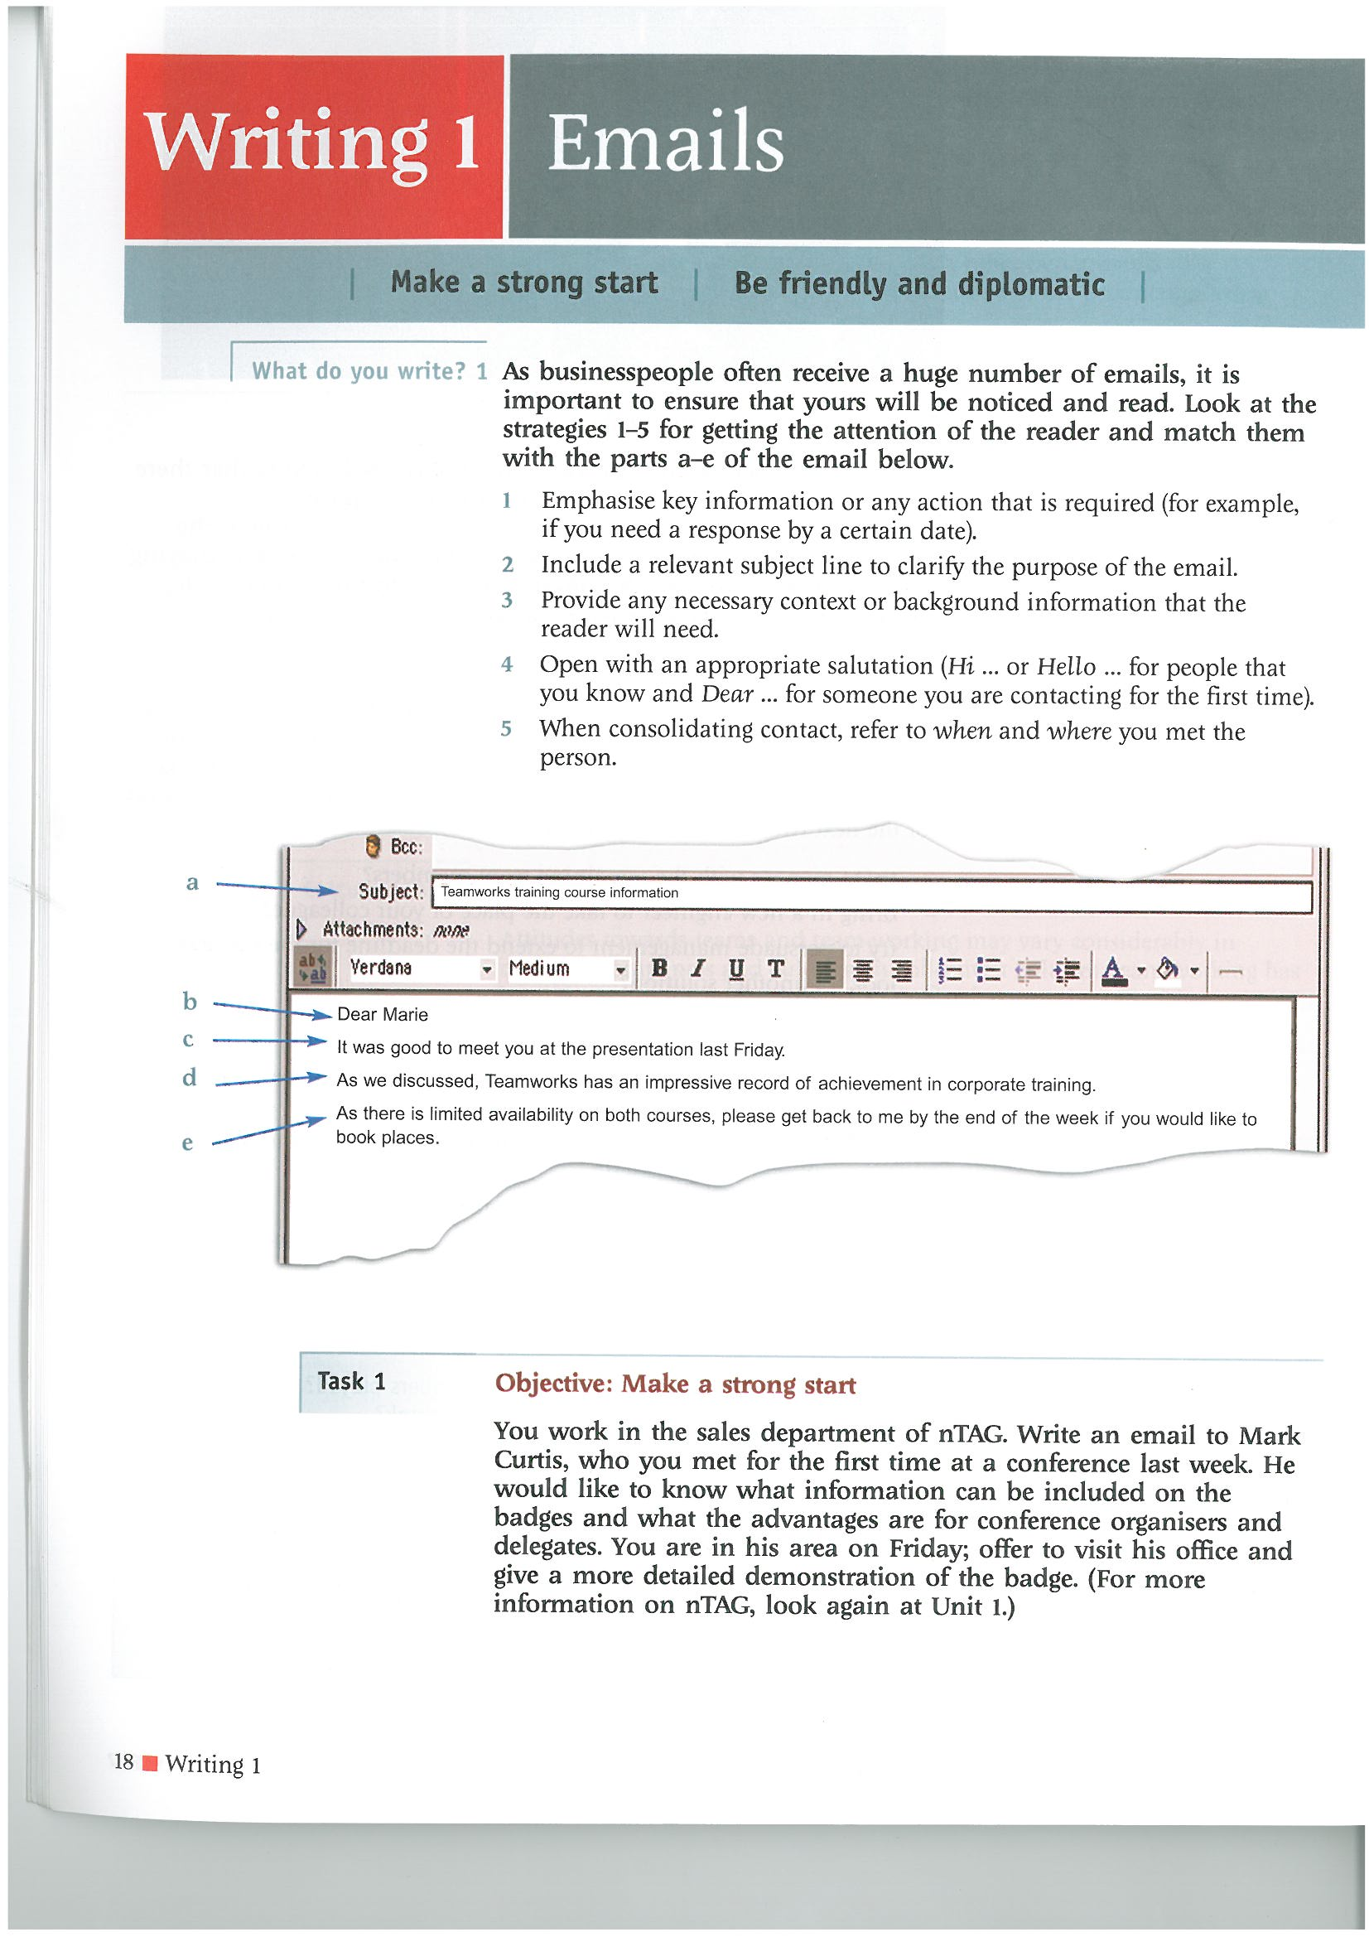*

**Context -** Many people now work in ‘virtual teams’, which means that all or almost all, of their communication is via email. However, it is still important to build a good relationship with other team members even if you don’t ever catch up with them.

**Scenario -** A US company is working with a Japanese distributor to launch a new model called the Titan in Japan.

The US manager replies to Yoshio Kurimoto about the planned launch schedule.

**\*Task** *Look at his email message below.*

**\*Task** *Discuss with a partner. Do you think the tone of it will help to build a good team spirit?*

*Why? Why not?*

*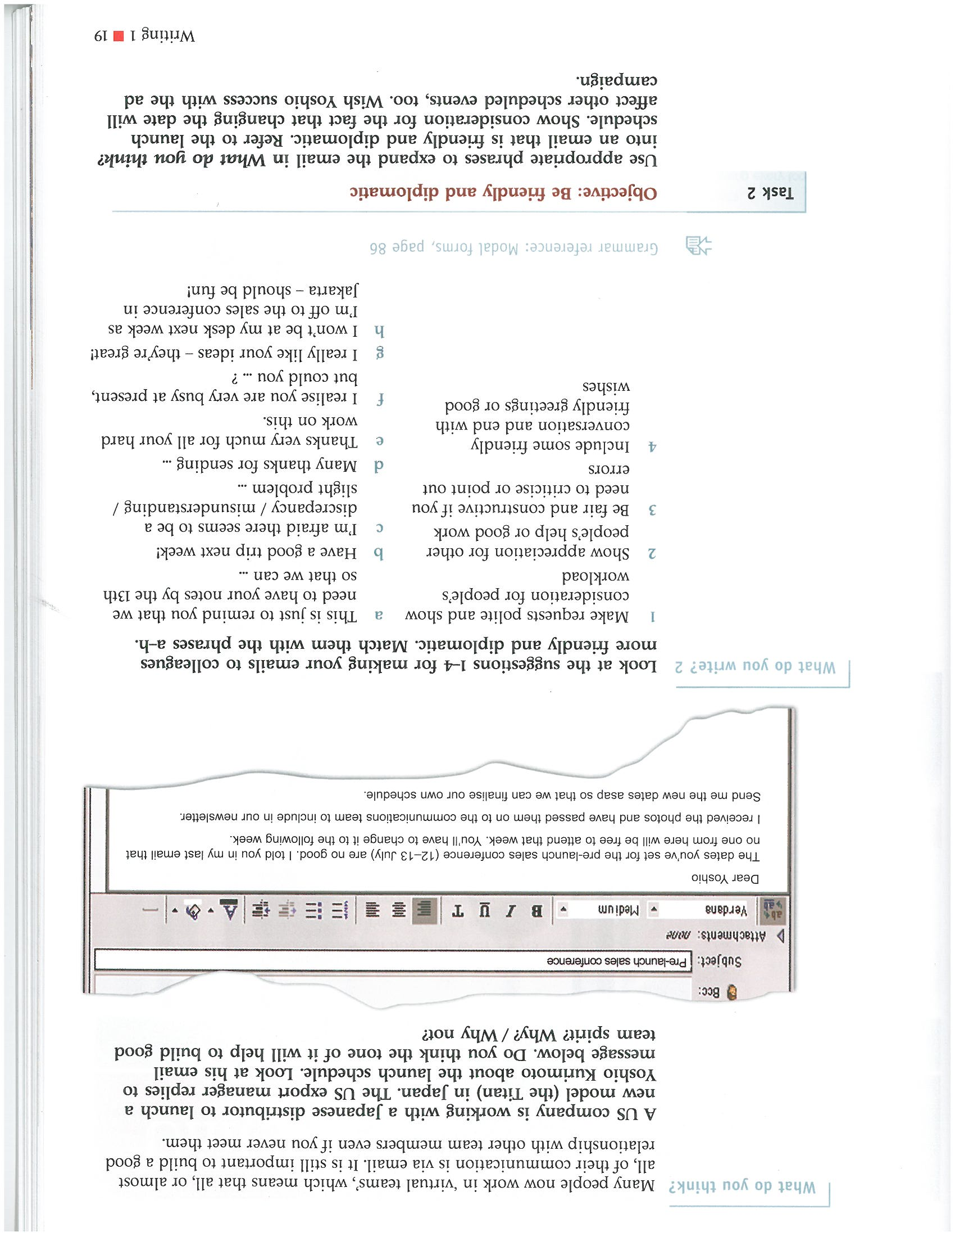*

**\*Task** *Look at these suggestions 1-4 for making your emails to colleagues more friendly and diplomatic.*

*Match them with phrases a-h.*

**

**(Pair Work - 3 minutes!)**

**\*Task** *Use appropriate phrases and softening words, such as those just presented, to expand the email sent to Yoshio**into an email that is friendly and diplomatic.*

*Refer to the launch schedule.*

*Urge him to change the date to the one previously discussed and to let you know ‘asap’.*

*Show consideration for the fact that changing the date will no doubt affect other scheduled events, too.*

***Do you want to politely point out that this mistake is really his fault?***

*Wish Yoshio success with the ad campaign.*

**

MORE FORMAL

*The tone of a formal email is similar to a business letter. However, as with all emails, the information should be concise.*

**\*Task** *Match the functions* ***1-6*** *to the parts of the email* ***a-f***

1. Bullet point or list information

2. Offer further assistance

3. State where you made the contact

4. Say why you are writing

5. Insert a clear subject sentence

6. Clarify any attachments

**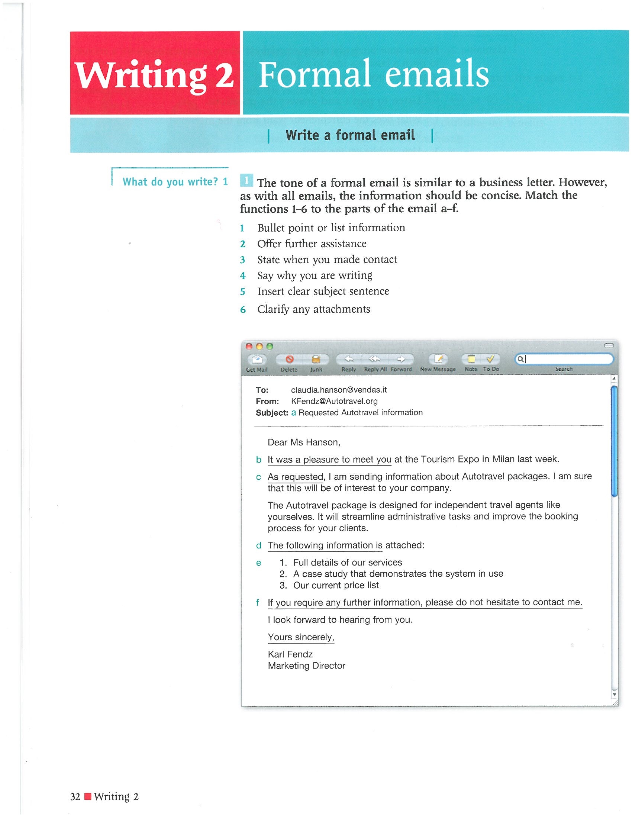**

**\*Task** *Can you easily express the underlined sections in the above email in other ways?*

**LEVEL OF FORMALITY**

*Countless emails are sent and received every day. Some are very informal, others may need to be far more formal.*

**\*Task** *Match the content 1-6 with the examples a-f. Can you think of any more examples?*

*Would you avoid using any of these in your workplace?*

*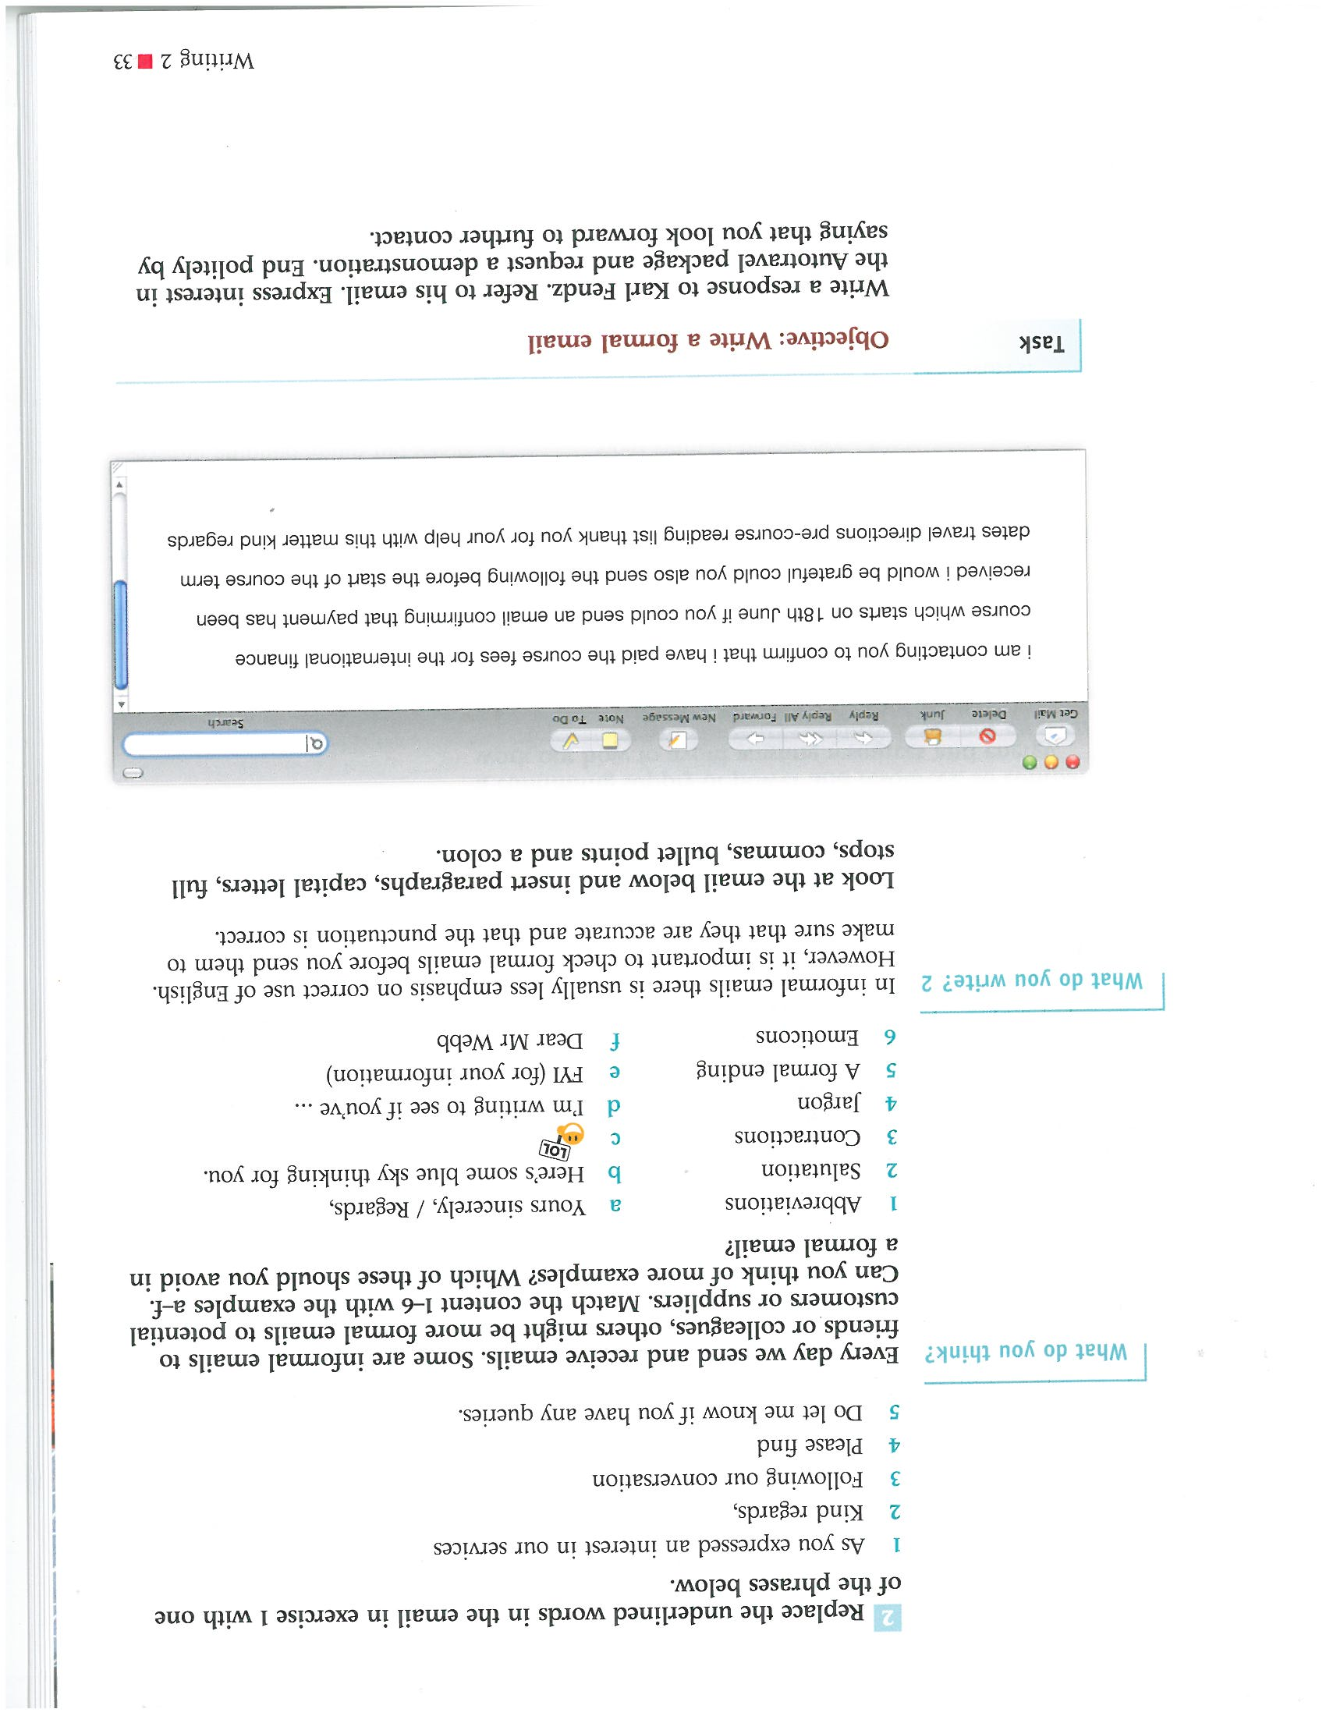*

*If an informal tone is okay, there is usually less emphasis on the correct use of English.*

*However,* ***always check before you send****.*

**ALWAYS** *look at spelling, punctuation and layout. No matter how ‘comfortable’ you are with the reader, make sure the message is still ‘digestible’!*

**Abbreviations and Acronyms**

Are you familiar with the following? Do you know any others that might be used in your field?

CEO

FAQ

p.a.

FYI

PAYE

AGM

TQM

CBD

COB

LIFO

Btw

IMO

pcs

**\*Task** *Can you think of any more that are commonly used in your own field/area of expertise?*

*?*

*?*

*?*

**\*NOTE\*** *Check that both writer and reader ‘speak’ the same language in terms of buzz words, jargon, acronyms and abbreviations.*

**\*Task** *Look at this email, and see what’s missing, then discuss possible changes with a partner.*

**\*Task** *Insert paragraphs, capital letters, full stops, commas, bullet points and a colon.*

**

*Clearly, below is an example of what* ***not*** *to do if you want a job!*

*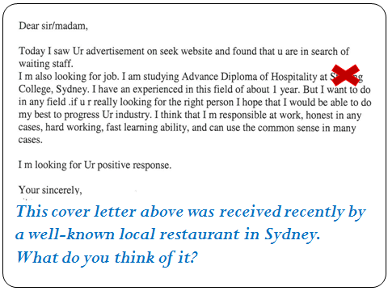*

**EXTENSION**

**Mixed Error Identification Tasks – Handout and PowerPoint Slides**

Which word? Choose one

1. I’d like you to give serious ***concern / consideration / ideas*** to this expansion plan.
2. Unfortunately, management is refusing to ***change / adapt / budge*** on this.
3. ***Broadening / Developing / Opening*** your horizons and trying something new is always healthy.
4. Sometimes it takes time to ***develop / work / grow*** into your role before you can do your job well.

Identify the mistake(s)

1. I’d be interested to hearing what you think about this new plan, because I’m beginning to have serious thoughts about our initial approach.
2. Out of the top of my head, I think last month’s sales figures were $23,000, but I can check double if you like.
3. I would like to have part of an NGO that can really achieve something good and I can really see a forecast for myself in this area.
4. When Emma’s away I’ll be expected to cover her work and I have to tell that I’m not really confident about that.

**\*REFLECT**

* *Did this exercise cause any problems for you?*
* *What suggestions does this audience offer to help you address language issues?*

*\*Workshop audience contributions*

|  |
| --- |
| **SUGGESTIONS**  *Example*  *Google this guy’s name. Leave your email address with Pearson BROWN, and maybe take the time to check out the free lessons he sends. Also, look at Caroline BROWN’s lessons which are often more about listening. Get what help you can for free.*   * *an app called grammerly (?)* |

**EXTENSION – COMMON MISTAKES 1 – BUSINESS WRITING**

**“ … to ‘ing’ or not to ‘ing’. That is the question.”**

(Material from ***Grammar for Business,*** M. McCarthy, CAMBRIDGE, 2013)

***\**TASK2 Emails –** *Find 12 mistakes in these 2 emails below.*

1.

*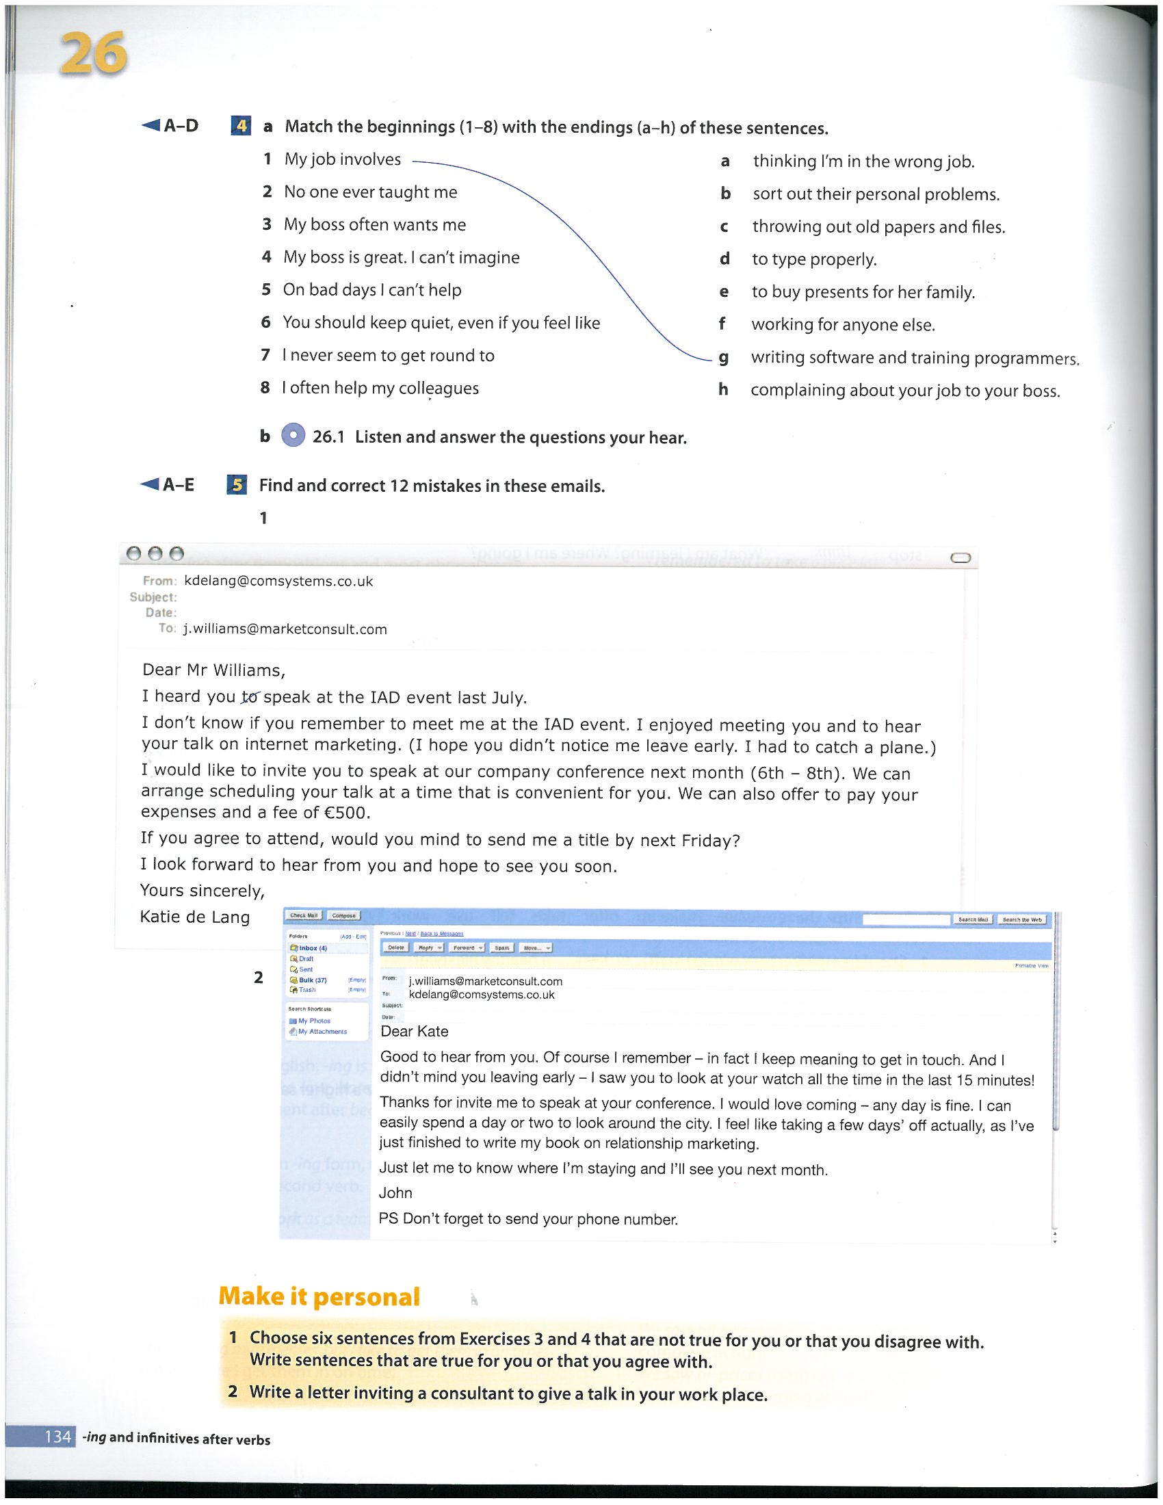*

2.

**

**Common Mistakes (2) Business Writing**

1. *Correct the mistake in each sentence.*
2. I hope we can to meet up soon.
3. Sorry, I don’t can help you with this matter.
4. I look forward to receiving this information as soon as possible.
5. I’m afraid but we haven’t received the delivery yet.
6. It would be more better if we could meet on Tuesday rather than Monday.
7. We note from our records that we haven’t received your payment still.
8. I apologies for the delay.
9. Exactly! I am agree with you.
10. I am really appreciate your kindness during my stay in Melbourne.
11. I am write with regard to your recent email.
12. Well, there’s something in my mind, and maybe you can help.
13. I hope I been of some help to you.
14. *Each sentence below has* ***one*** *word missing.* ***Add the missing word.***
15. If you like any more details, just let me know.
16. With reference your email sent July 28, …
17. What time would convenient for you?
18. I apologise the delay.
19. I look forward to hearing you soon.
20. I’ve attached a copy the latest sales figures.
21. What time would convenient for you?
22. If you like any more details, just let me know.
23. I was wondering you had any ideas about …
24. Hope that advice helps but it’s your decision, and only you can make that decision the end.
25. I am attaching our latest price list and catalogue as pdf.
26. Thank you for your email inquiring our latest product line.
27. Each ***paragraph*** in the emails below has ***three*** mistakes. Correct the mistakes. The first mistake in Email 1 has been identified for you, as an example.

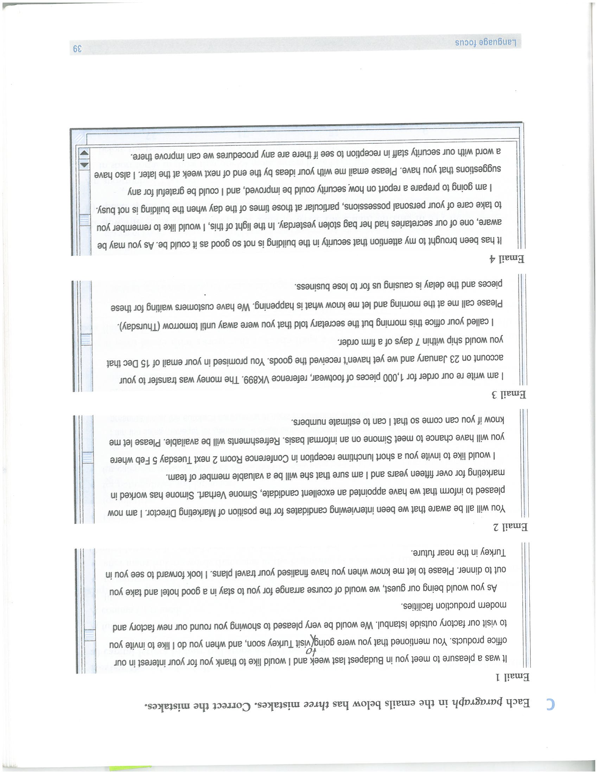

From ***Email English***, Paul Emmerson, U16, MACMILLAN

**Attachments - Language**

1. *Identify* ***one key mistake*** *in each sentence below*
2. Sorry, I forgot send the attachment!
3. Sorry you couldn’t open the document – I have attach it again.
4. Here’s the copy of Jack’s report – what you think?
5. Returning your original document with my comments inserted with red.
6. Thanks for sending me the report – I let you know what I think.
7. *In each gap in the sentences below, there are two options in blue that can complete the sentence correctly.* ***Choose the two correct options*** *from* ***a/b/c/d.***

1) I’m sending various forms for you to complete before arrival. Please \_\_\_\_\_\_\_\_\_ special attention to AFZ200 **a) give b) pay c) make d) take**

2) Please complete the attached forms and return them to me \_\_\_\_\_\_\_\_\_ 10 February  **a) by b) until c) before d) to**

3) I’m attaching the Business PlanReview. Please \_\_\_\_\_\_\_\_\_\_ that several alterations in dates have been made. **a) look b) appoint c) note d) be aware**

4) Please find attached my report.\_\_\_\_\_\_\_\_\_\_\_\_ .

**a) Let me know what you think b) Let me have any comments c) Let me have what you think d) Make me have any comments**

5) Here is the itinerary for the Sydney conference. Please \_\_\_\_\_\_\_\_\_\_\_ that I have included everything you want in it. **a) check b) agree c) control d) confirm**

***C.*** *Complete the email texts below with just one suitable word in each gap.*

|  |
| --- |
| **1) \_\_\_\_\_\_\_\_\_\_ agreed, I’m sending the pre-meeting notes. Let me know if there’s anything \_\_\_\_\_\_\_\_\_\_\_ we can do from this \_\_\_\_\_\_\_\_\_\_\_\_ before we meet.** |

|  |
| --- |
| **2) I \_\_\_\_\_\_\_\_\_\_\_\_ be grateful if you \_\_\_\_\_\_\_\_\_\_\_\_\_ complete the attached form and return it asap. Please \_\_\_\_\_\_\_\_\_\_ that there is a change to my email address.** |

**General Guidelines**

* Begin all more correspondence with ***Dear*** + the appropriate form of address

Dear ***Mr Smith / Dear John / (Dear Sir / Madam*** if you don’t know the name)

* It is none of your business if a woman is single or married!

Play it safe by using ***Dear Ms*** + her family name. This is now the correct form of address even if you actually know she is married.

* Correspondence beginning with ***Dear Mr Smith***, ends with ***Yours sincerely/Kind regards***

Correspondence beginning with ***Dear Sir / Madam*** always ends with ***Yours faithfully***

* Usually stick to the active rather than the passive voice (for example, instead of ‘***Your order has been received’***, write ‘***We have received your order’***, Instead of ‘***With reference to …***’, write ‘***I refer to …***’ etc).

**NOTE**

Use the passive voice more if your intention is to distance yourself from the information you are giving, or to ‘depersonalise’ the message.

* Ordinal numbers (for dates, e.g., ***the first of November***, ***the seventh of April***) are sometimes followed by letters (e.g., ***1st November***, ***7th April)***, but this is less common now. It is too time consuming. Now, ***1 November***, ***7 April***, etc., is more common and saves time.
* Avoid using abbreviated dates in your written correspondence (e.g., 12/11/10). It can cause confusion.
* Think about the layout of your written communication. Present it in ‘digestible bites’ of information. When you Point the Way Forward (i.e. future action), set it clearly apart in a new paragraph.
* Be consistent in your punctuation. If you have a comma after ***Dear John***, place a comma after ***Yours sincerely***.

If you don’t have the comma at the top, don’t have one at the bottom.

* Note that modern business communication should be brief. The message you want to communicate should be done in the most economical way, while remaining clear and polite.

The acronym KISS means Keep it short and simple. 

NOTE

Any guideline that applies to the first contact in writing with a business or client, also applies to first contact emails. Use a more formal tone. In emails, however, with subsequent contact, the level of formality drops more quickly, particularly in Australia.

Also, you need to bear in mind the *culture of the company* you work for.

**EDITING FOR ACCURACY**

**Checking & Correcting Language**

**“Proofread carefull to see if you any words out”**

(From ***WRITING - English for Business***, U 16, Nick Brieger, COLLINS, 2011)

**\*DISCUSSION TASK**

What areas of business writing do you think you have the most problems with?

Language covers the areas of:

1. Grammar 4. Sentence linking
2. Vocabulary and expressions 5. Sentence structure
3. Spelling 6. Sentence length

**NOTE**

For language to be described as ‘accurate’, the writer must apply all of these language areas correctly.

It probably won’t be achieved in the first daft, but this slows down the process of writing. Decide on the appropriate content, structure and style, working on following a procedure for writing, and in the final time left available to you, focus on the language areas.

**FLOW CHART**

|  |
| --- |
| 1. Think about your readers |



|  |
| --- |
| 1. Make a start: collect your information |



|  |
| --- |
| 1. Select the information (concentrate on content) |



|  |
| --- |
| 1. Write your first draft (concentrate on structure and style) |



|  |
| --- |
| 1. Review and edit (concentrate on structure, style and language) |



|  |
| --- |
| 1. Revise and write final draft (concentrate on all areas) |

**\*\*NOTE** The quote at the beginning of this should read “Proofread carefully to see if you have left any words out”

The previous FLOW CHART illustrates that you should focus on the editing of your language in Stages 5 and 6, ***after*** you have made all the key notes for the first draft.

Only then can you really keep your focus on just the language areas. Carefully check these for the following and try to avoid the obvious ‘pitfalls’.

The following extracts come from business documents and they contain common mistakes in grammar, spelling and vocabulary (word choice).

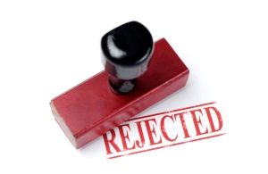

**\*COMMON MISTAKES 3 TASK - PAIR WORK**

Correct the mistake(s) in each one

1) Regarding to your recent enquiry, we are pleased to inform you that the goods are now in stock and will be maled out to your later today.

2) According with our records, we have not recieved payment for our invoice dated 11 September.

3) Our payment term clearly state that payment is due within 30 days. Payment should therefore have beeen received until October 12.

4) Could you please provide us with more informations about your requirements. We will then be able to respond in more details.

5) Could you please explain more precisely what you mean with ‘unexpected delay to our delivery’?

6) I regret inform that the goods you ordered will not be in stock until next mouth.

7) I am writing to confirm you the details of our meeting, which will be at October 15th at 2.30pm.

8) I can absolutely ensure you that the information will be treated in the strictest confident.

9) Do not hesitate to contact us again if you have any farther qestion.

10) I look forward to hear from you as soon you have read through the report.

**KEY STRUCTURES IN BUSINESS REPORTS - GRAMMAR FOCUS**

\*Task Match beginnnings with endings. Look for the logical connections.

1. As requested at the Board meeting …
2. The purpose of the report is …
3. The report is based …
4. I have divided the report …
5. As can be seen …
6. This has led to a situation …
7. As mentioned …
8. I suggest that the company …
9. My specific recommendations …
10. Please have a look at …
11. Your comments will be circulated …
12. Please feel free …
13. … on the figures sent to me by different departments
14. … where cost-cutting measures are necessary.
15. … in table 1, demand has been falling.
16. … to suggest ways to reduce costs.
17. … into three sections.
18. … of June 30, here is my report.
19. … the full report and let me have your comments.
20. … are as follows:
21. … to contact me if you have any questions.
22. … should be able to cut costs significantly.
23. … above, sales are going down.
24. … in time for the next meeting.

**EXTENSION - REPORT LANGUAGE 1**

(Using key language)

(adapted from ***Email English***, P. Emmerson, MACMILLAN)

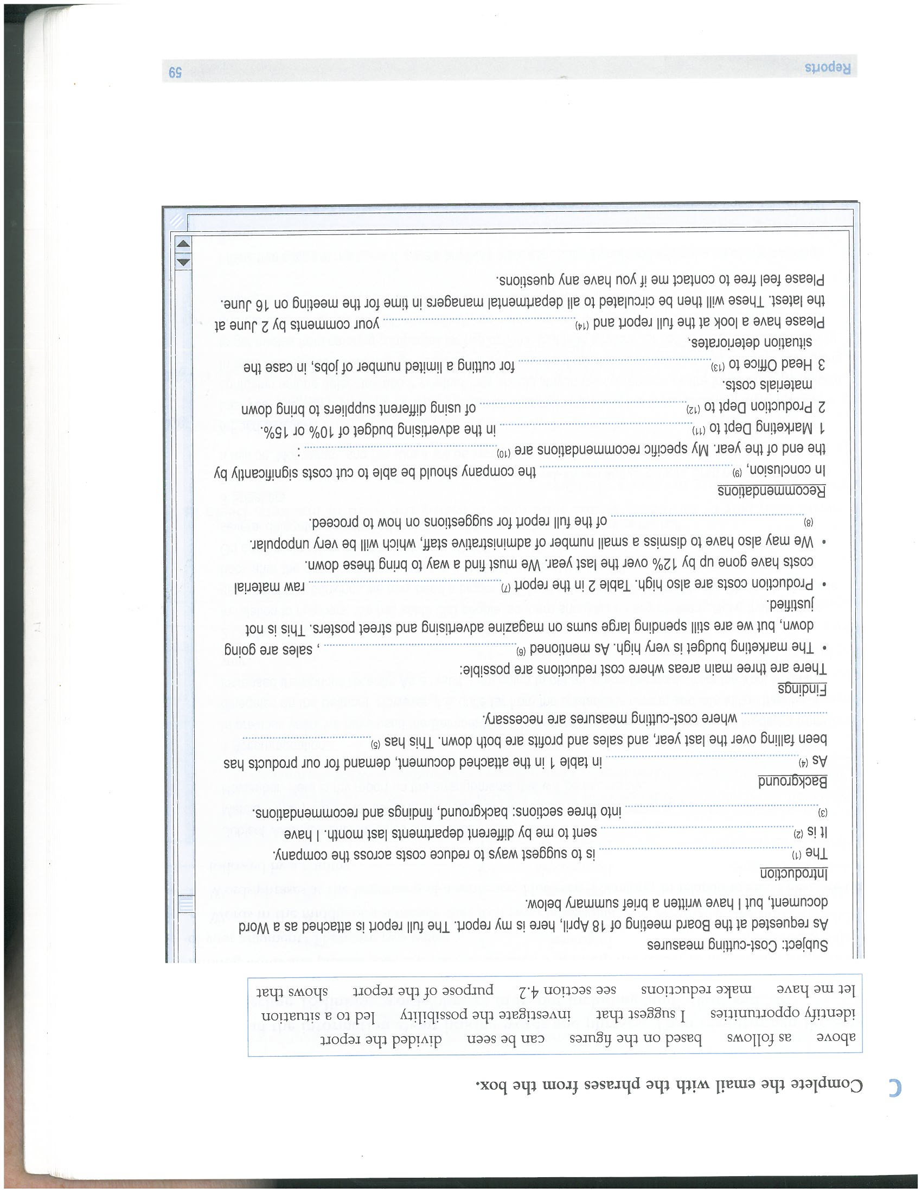

**\*TASK** *What can complete the gap in the report above? There is only one* ***best*** *answer for the spaces.*

|  |
| --- |
| **above / as follows / based on the figures / can be seen / divided the report /**  **/ shows that /identify opportunities / I suggest that / let me have / investigate the possibility / led to a situation / make reductions / see section 4.2 / purpose of the report /** |

**EXTENSION - REPORT LANGUAGE 2**

(Working on levels of formality)

The highlighted phrases in the following report are **too informal, or too personal in tone**.

**\*TASK** Use the word groups in the box to replace them with more formal equivalents.

Change verbs or nouns where it is necessary.

|  |
| --- |
| /account for / slightly / more than half / total membership /afraid of / sanctions / employers /  / can be found / appendix / explore / attitudes / investigate / possible causes for / major factor / failure / workers / there is / lack / information / general public / we / experience / alarming drop / union membership / what benefits / unon / provide / with the purpose / educating / workforce / on / |

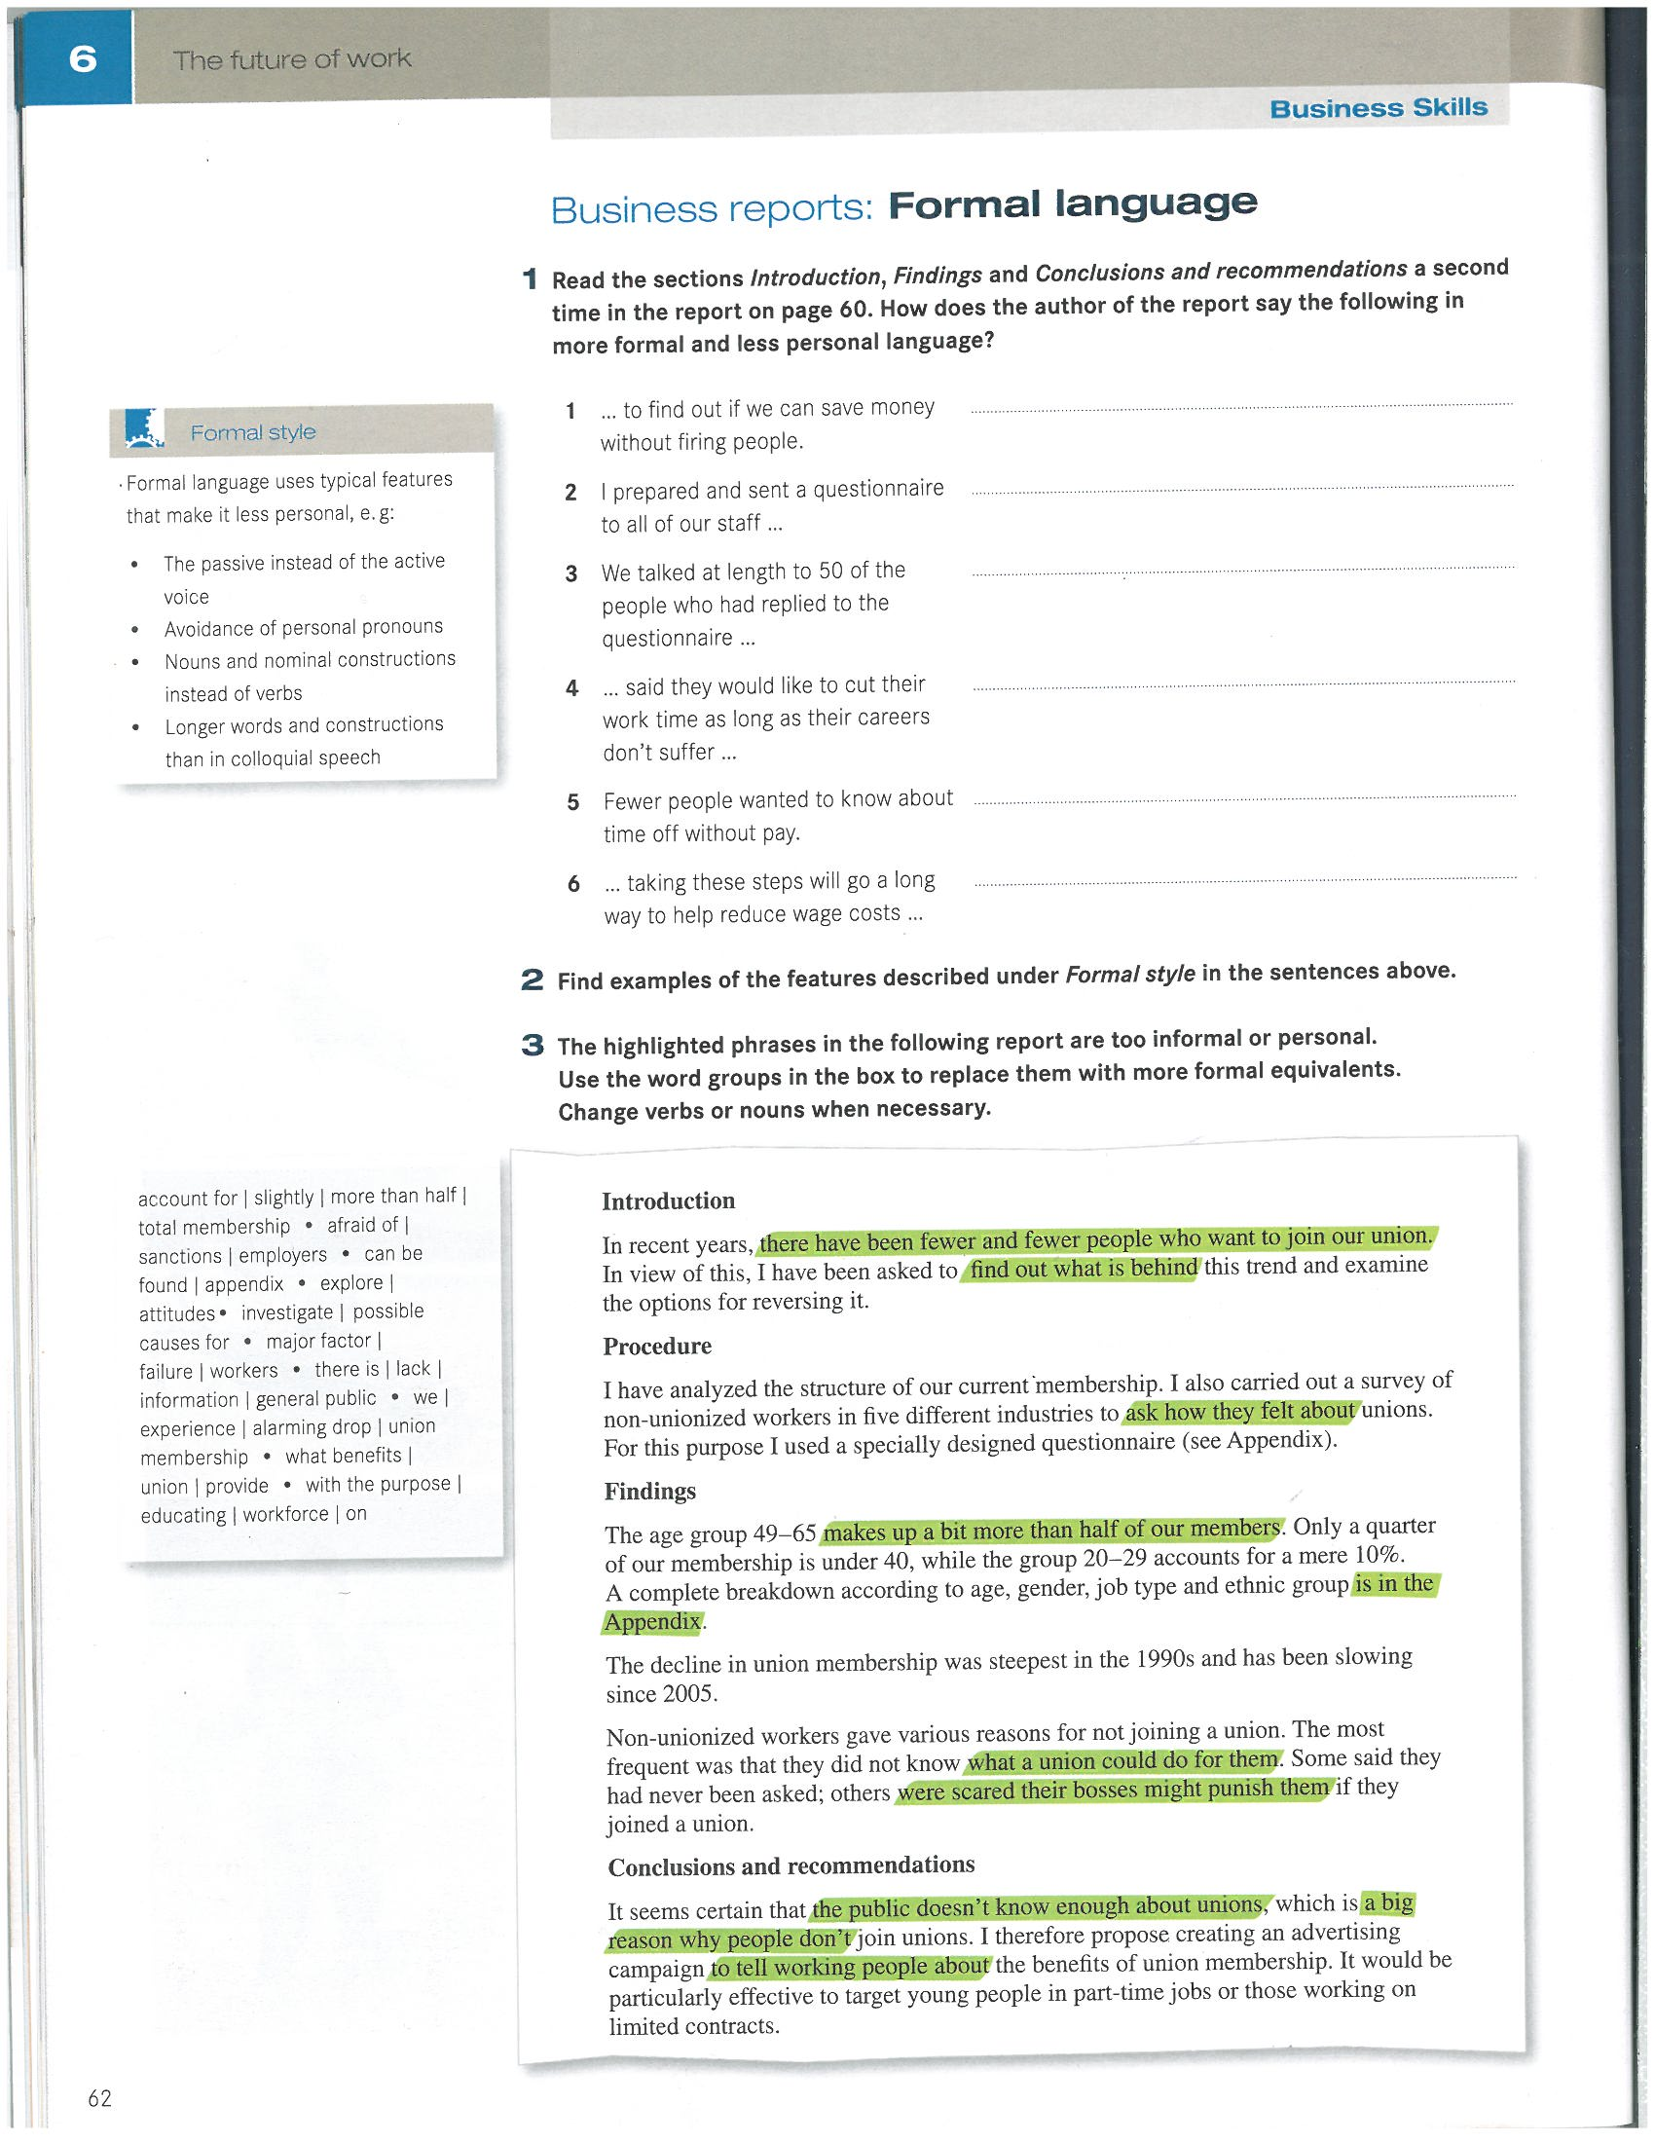

**ANSWERS AND SELF CORRECTION**

\*2 emails (self- correct) “to ‘ing’ or not to ‘ing’. That is the question.

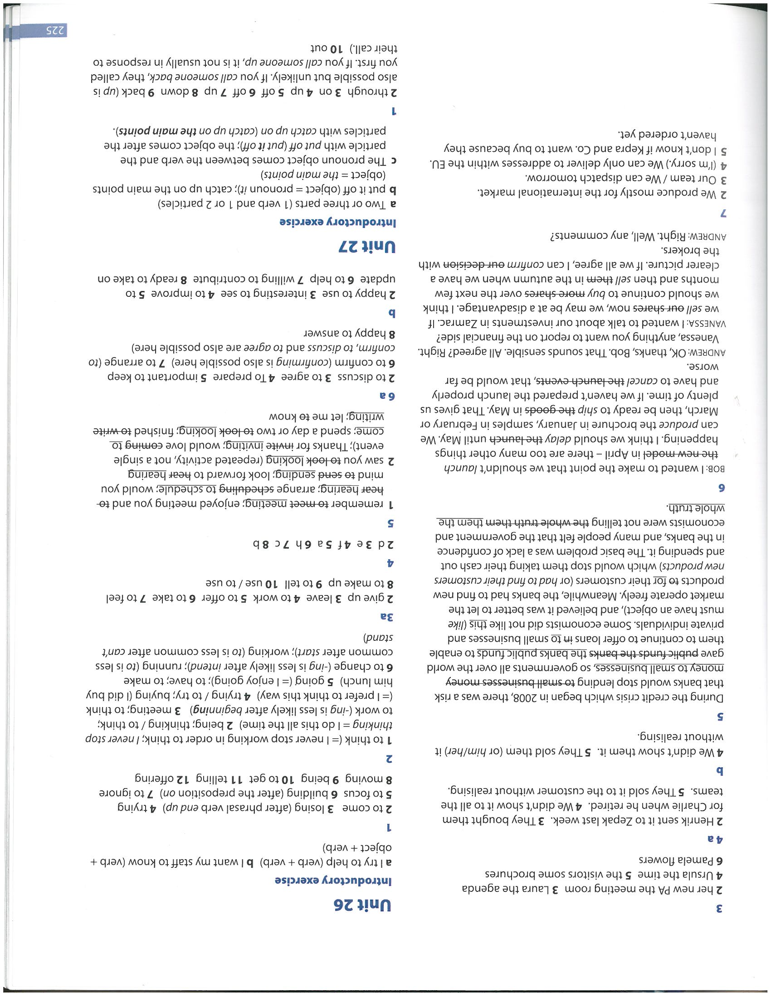

\* Common mistakes in emails (self-correction)

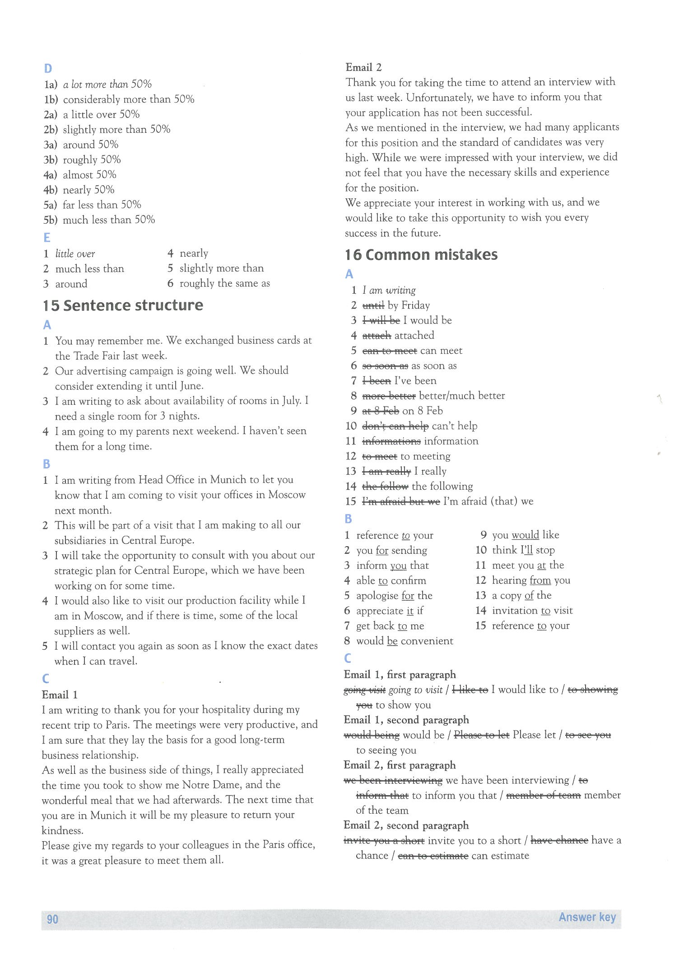

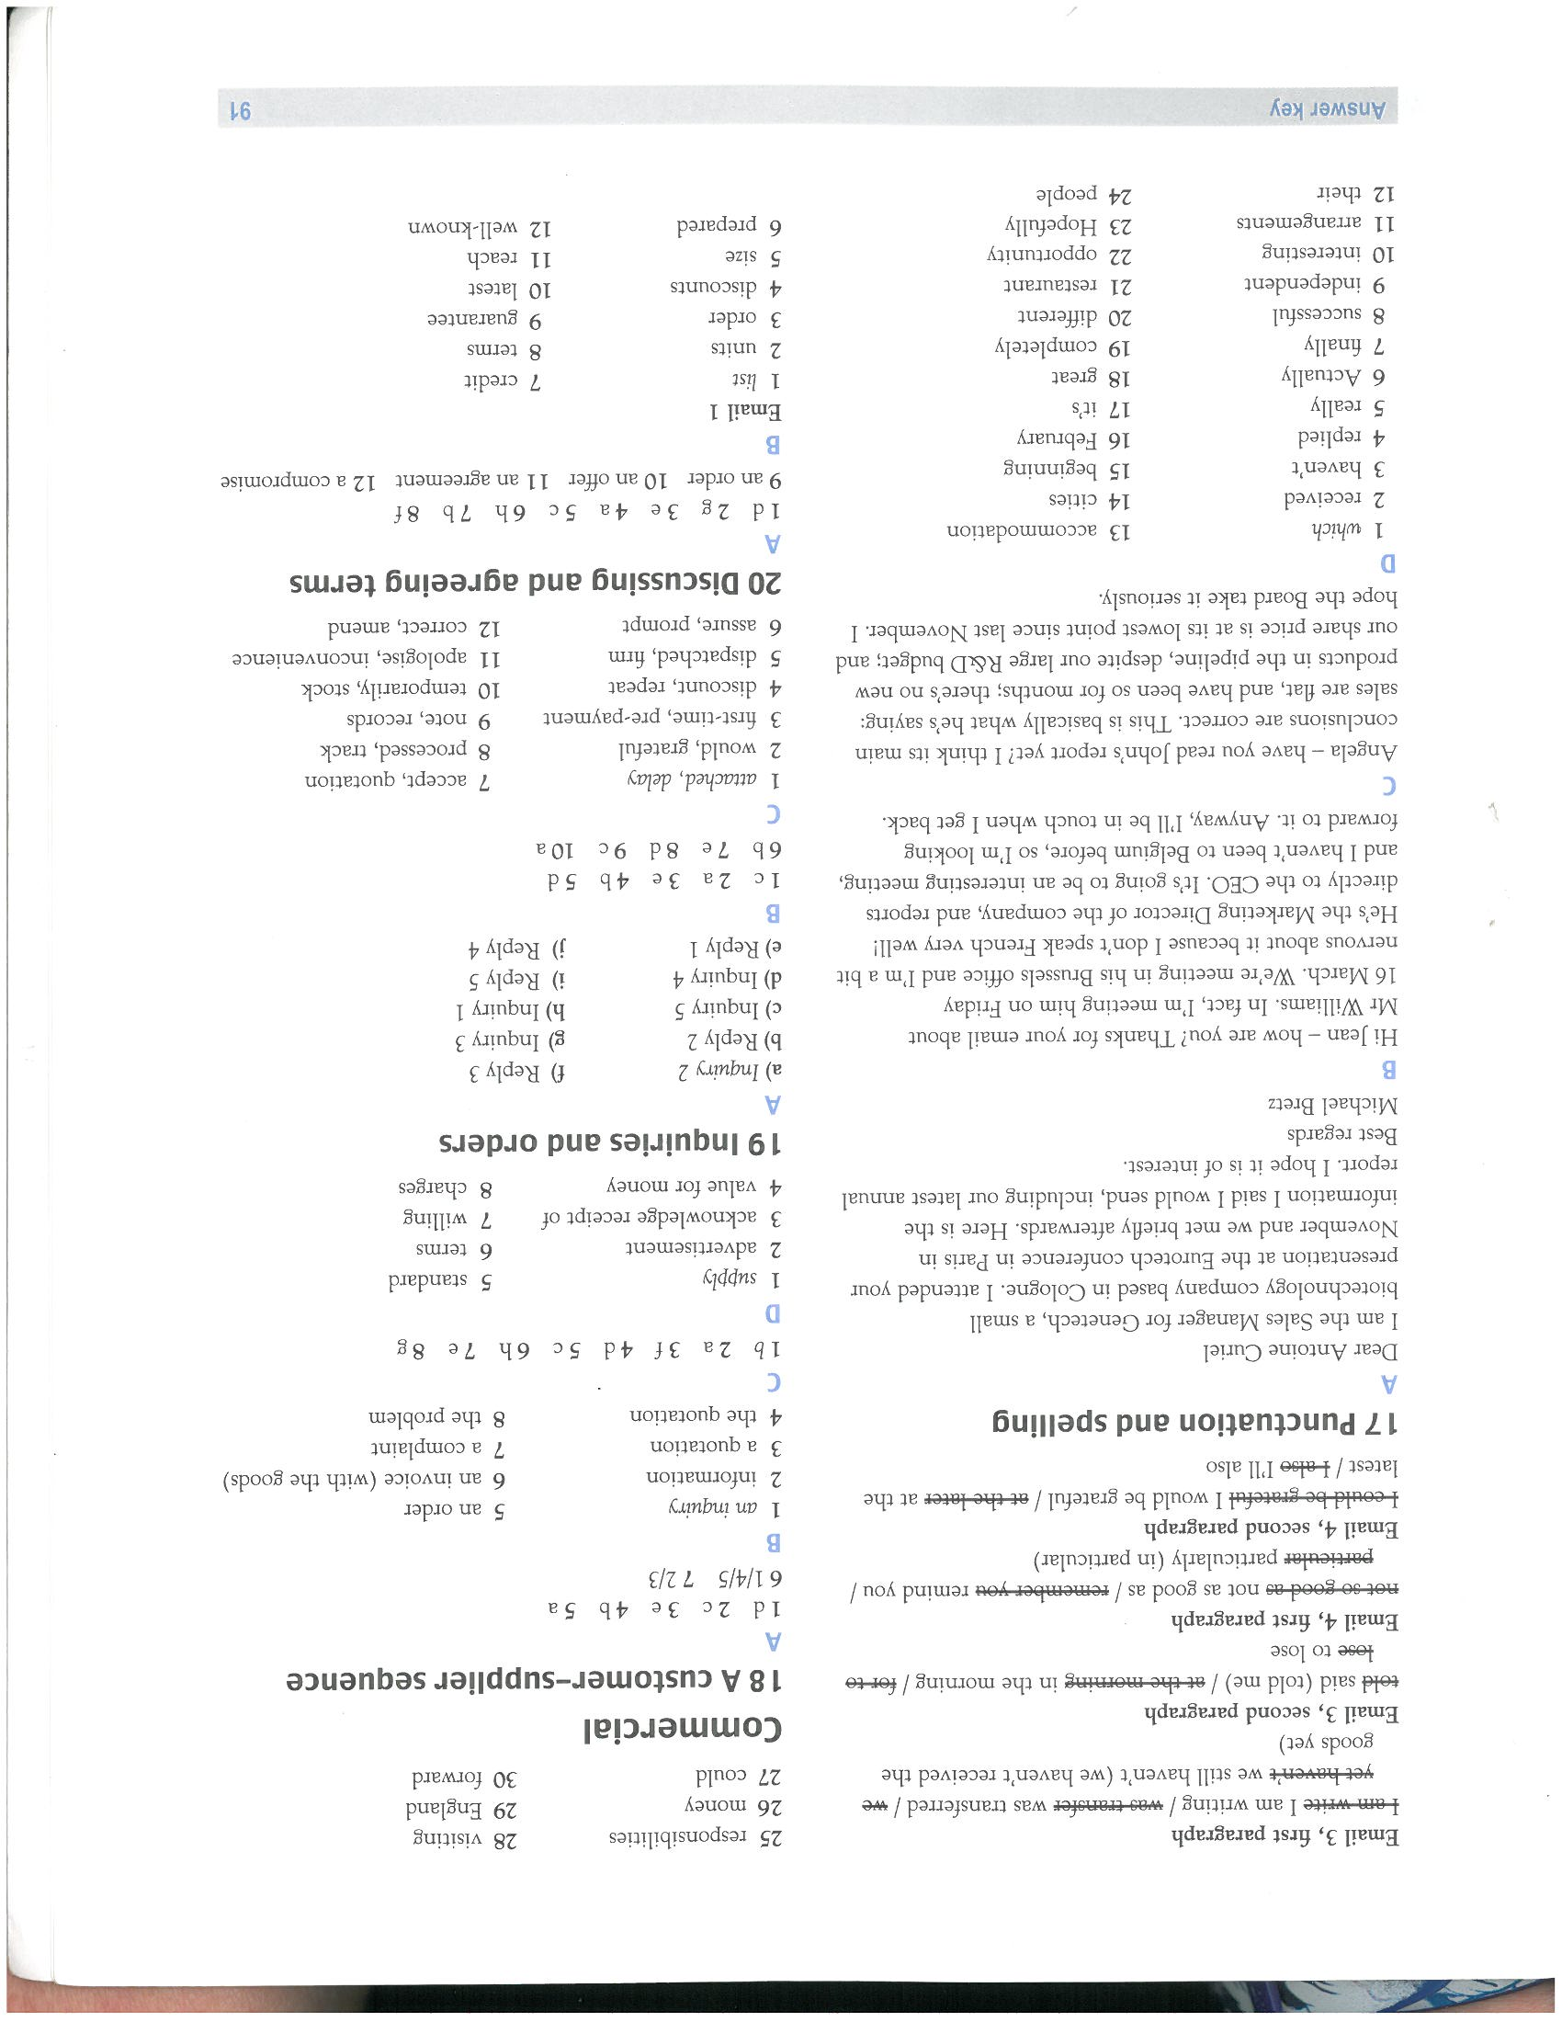

\*Pair work task - area of problem is indicated in red.

1) Regarding ~~to~~ your recent enquiry, we are pleased to inform you that the goods are now in stock and will be ~~maled~~ (mailed) out to ~~your~~ (you) later today.

2) According ~~with~~ (to) our records, we have not recieved (received) payment for our invoice dated 11 September.

3) Our payment ~~term~~ (terms) clearly state that payment is due within 30 days. Payment should therefore have beeen received ~~until~~ (by) October 12.

4) Could you please provide us with more ~~informations~~ (information) about your requirements. We will then be able to respond in more ~~details~~ (details).

5) Could you please explain more precisely what you mean ~~with~~ (by) ‘unexpected delay to our delivery’?

6) I regret (to) ^inform (you) ^that the goods you ordered will not be in stock until next ~~mouth.~~ (month)

7) I am writing to ~~confirm you~~ (confirm with you) (confirm) the details of our meeting, which will be ~~at~~ (on) October 15th at 2.30pm.

8) I can absolutely ~~ensure~~  (assure) you that the information will be treated in the strictest ~~confident.~~ (confidence)

9) Do not hesitate to contact us again if you have any ~~farther~~ ~~qestion~~. (further questions)

10) I look forward to ~~hear~~ (hearing) from you as soon ^ (as) you have read through the report.

|  |  |
| --- | --- |
| Report 2 (levels of formality answers)  X:\ScannedDocuments\L5\SKonica652_14102409522.jpg | Report 1 (key language answers)  1. purpose of the report  2. based on the figures  3. divided the report  4. can be seen  5. led to a situation  6. above  7. shows that  8. See section 4.2  9. I suggest that  10. as follows  11. make reductions  12. investigate the possibility  13. identify opportunities  14. let me have |

**Punctuation and layout exercise**

**ANSWERS**

**I** am contacting you to confirm that **I** have paid the course fees for the **I**nternational **F**inance course which starts on 18th **J**une**.**

**I**f you could send an email confirming that payment has been received**,** **I** would be grateful**.**

**C**ould you also send the following before the start of the course**:**

**-**term dates

**-**travel directions

**-**pre-course reading list

**T**hank you for your help with this matter**.**

**K**ind regards**,**

**Dear Yoshio Suggested Answer**

\*\*Could you make it shorter, but still keep a polite, friendly tone, while including all the info necessary?

Hi Yoshio

*Regarding the launch schedule you’ve proposed, I’m afraid we’ve got a bit of a problem. As mentioned in my email (March 1), no-one from our US team can be there that week. My suggestion is to reschedule it for the following week.*

*Please confirm the rescheduled dates quickly. COB Friday? We’ll need to make staffing arrangement, flights etc. for our team here. I know you have a lot of other things on your plate to arrange, but this info is urgent.*

*Many thanks for all the great work done getting those photos together. They were great! The communications team have them and they’ll be included in the next newsletter.*

*Wish you all the best for the ad campaign.*

*Please let me know the new dates as quickly as possible. The team really look forward to meeting you.*

Regards

Dan

**ANSWERS FOR DOUBLE-CHECKING**

**Report - Key Structures**

**Matching beginnings with endings**

**